OUR LADY IMMACULATE CATHOLIC PRIMARY SCHOOL
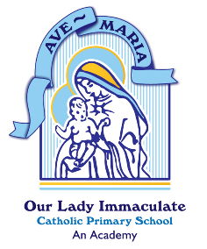
“With God all things are possible”
(Matthew 19:26)

At Our Lady Immaculate Catholic Primary School, we will inspire our children to achieve personal excellence for themselves and for the glory of God.

Privacy Notice
Publishing Pupil Coursework

SIRO | Lesley Roche
Approved by | The Full Governing Body
Date Approved | Spring 2023
Review Date | Spring 2024

Publishing pupils’ coursework

We may wish to celebrate the achievements of pupils and promote the School through publishing of coursework. When this is the case, we will seek the consent of the parent/carer, or where pupils are aged 12 or above, from the pupil themselves. As we are relying on your consent you can withdraw consent at any time by contacting the school. Every effort will be made to delete the coursework, but please note that where consent has been provided for the publication, the school may not be able to locate and delete the coursework on request, although reasonable steps will be taken to do so.

Where consent has been provided for the use of coursework, and the pupil has left the school, we will rely on legitimate interests as our legal basis when retaining coursework for promotional purposes. If you would like a copy of the Legitimate Interest Assessment we have completed for this activity, please contact the school office.

The personal information likely to be used in this activity is:
- Student Name
- School Year
- Coursework

The school is the Data Controller for this information. The information might be shared with:
- Other students
- Social Media applications
- School website providers

No coursework is routinely available outside of the UK. However, where it is used on used on social media, in publications, or on our website we cannot restrict the access to the UK.

For information about your rights in relation to this use of your personal information please see section 5 of our overarching privacy notice.

