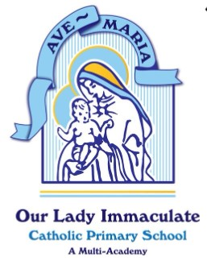
With God all things are possible’ (Matthew 19:26)
Prayer and Liturgy Calendar 2023/2024
All whole school masses are led by the Chaplaincy Team
September | - Staff Mass to begin new term  - Weekly Class/Parish Masses begin  - Whole School Mass to celebrate New Year
October | - Weekly Class/Parish Masses
November | - Whole School Mass - Holy Day of Obligation – All Saints Day  - Weekly Class/Parish Masses
December | - Weekly Class/Parish Masses  - Whole School Mass to celebrate Patronal Feast Day  - Nativities  - Junior Carol Service in Church  - Advent Reconciliation Service  - Candlelit Service
January | - Weekly Class/Parish Masses  - Whole School Mass – Epiphany Week
February | - Weekly Class/Parish Masses  - Whole School Mass – Ash Wednesday
March | - Easter Service – in Church
April | - Weekly Class/Parish Masses
May | - May Procession  - Whole School Mass – Family Day
June | - Weekly Class/Parish Masses  - Staff Inset – Retreat – New Hall  - Year 6 Retreat – New Hall
July | - Weekly Class/Parish Masses  - Year 6 Leavers Mass and Prize Giving

Weekly Prayer and Liturgy
Monday | Headteacher’s Assembly (Sunday’s Gospel, Virtues to live by, Special Feast Days)
Tuesday | DHT’s assembly (Catholic Social Teaching)
Wednesday | Mark 10 Mission (in class)
Thursday | Whole School Hymn Practice
Friday | Headteacher Celebration Assembly

