OUR LADY IMMACULATE CATHOLIC PRIMARY SCHOOL
“With God all things are possible”
At Our Lady Immaculate Catholic Primary School, we will inspire our children to achieve personal excellence for themselves and for the glory of God.

Marking and Feedback Policy

Date | Review Date | Coordinator | Nominated Governor
Autumn 2022 | Autumn  2024 | Headteacher | Linda McSweeney

Lady Immaculate Catholic Primary School
Marking and Feedback

At Our Lady Immaculate we recognise the importance of feedback as part of the teaching & learning process, and aim to maximise the effectiveness of its use in practice. We are mindful also of the workload implications of written marking, and of the research surrounding effective feedback.
Our updated policy is underpinned by the evidence of best practice from the Education Endowment Foundation and other expert organisations. The Education Endowment Foundation research shows that effective feedback should:
- redirect or refocus either the teacher’s or the learner’s actions to achieve a goal
- be specific, accurate and clear
- encourage and support further effort
- be given sparingly so that it is meaningful
- provide specific guidance on how to improve and not just tell students when they are wrong
Notably, the Department for Education’s research into teacher workload has highlighted written marking as a key contributing factor to workload. As such, we have investigated alternatives to onerous written marking, which can provide effective feedback in line with the EEF’s recommendations, and those of the DfE’s expert group. Both professional bodies emphasise that marking should be: meaningful, manageable and motivating. We have also taken note of the advice provided by the NCETM (National Centre for Excellence in Teaching Mathematics) that the most important activity for teachers is the teaching itself, supported by the design and preparation of lessons.

Key Principles
Our policy on feedback has at its core a number of principles:
- the sole focus of feedback and marking should be to further children’s learning;
- evidence of feedback and marking is incidental to the process; we do not provide additional evidence for external verification;
- written comments should only be used where they are accessible to students according to age and ability;
- feedback delivered closest to the point of action is most effective, and as such feedback delivered in lessons is more effective than comments provided at a later date;
- feedback is provided to pupils as part of assessment processes in the classroom, and takes many forms other than written comments;
- feedback is a part of the school’s wider assessment processes which aim to provide an appropriate level of challenge to pupils in lessons, allowing them to make good progress.
- All pupils’ work should be reviewed by teachers at the earliest appropriate opportunity so that it might impact on future learning. When work is reviewed, it should be acknowledged in books.
Within these principles, our aim is to make use of the good practice approaches outlined by the EEF toolkit to ensure that children are provided with timely and purposeful feedback that furthers their learning, and that teachers are able to gather feedback and assessments that enable them to adjust their teaching both within and across a sequence of lessons.

Feedback and marking in practice
It is vital that teachers evaluate the work that children undertake in lessons, and use information obtained from this to allow them to adjust their teaching. Feedback occurs at one of three common stages in the learning process:
1. Immediate responsive feedback – at the point of teaching
- Summary feedback – at the end of a lesson/task
- Review feedback – away from the point of teaching (including written comments)
The stages are deliberately numbered in order of priority, noting that feedback closest to the point of teaching and learning is likely to be most effective in driving further improvement and learning, especially for younger pupils. As a school, we place considerable emphasis on the provision of immediate responsive feedback. Where feedback is based on review of work completed, the focus will often be on providing feedback for the teacher to further adapt teaching. Review Feedback will usually take the form of whole class feedback (See Appendix).

Marking Approaches
All work will be acknowledged in some form by class teachers. This may be through simple symbols such as ticks or arrows or referencing the learning objectives.
In Foundation Stage & Key Stage 1, review marking will only lead to written comments for those pupils who are able to read and respond independently. In some cases, the marking code may be used where this is understood by pupils (see end of policy for marking code & symbols). Where pupils are unable to read/understand such comments, these are shared verbally with children at the next appropriate opportunity and teachers will use ticks to acknowledge the work has been checked.
In Key Stage 2, written marking and comments should be used where meaningful guidance can be offered which it has not been possible to provide during the classroom session or during the whole class feedback session. In the case of groups of pupils having a common need, it may be appropriate for teachers to adjust planning or grouping rather than providing a written comment. Where a child has achieved the intended outcome and is well prepared for the next stage in learning, this need not be annotated. Instead, using the marking code, work will be ticked to show it has been checked.
Extended pieces of written work, or extended tasks will be marked for spellings and grammar but a whole class feedback sheet will be completed, instead of lengthy comments for individual children. Teachers will use the whole class feedback sheet to praise specific children, address basic skills errors and misconceptions and deliver relevant teaching points to the whole class in the next lesson. Any children requiring 1:1 feedback will receive this.

Marking Code
Where written marking or annotations are appropriate, the intention is that minimum teacher time should lead to maximum outcomes. One way in which we achieve this is through the use of our marking code, which combines use of ticks and symbols codes. Highlighter pens may be used to demonstrate grammatical features that need a visual cue for support. The core of this code is set out below, although some additional age appropriate elements may be included in some phases of the school.

 | MARKING CODE
Annotation | Meaning
 | Against the learning objective | Within a piece of writing
 √ | Work checked. | I like this
√√ | Work checked and it meets the learning objective. | I really like this.
√√√ | Work checked and it exceeds the learning objective. | This is excellent
^ | Something is missing
 | There is an error on this line that needs addressing
    SP | Spelling error **  In KS1 this will usually be accompanied by the corrected spelling or spelling pattern. In KS2, depending on age/ability, correct spellings will be given and then practise the word.
h/w | Handwriting needs practising (a specific letter or join will be modelled)
// | New paragraph needed.
 | Next step – can be used if whole class feedback is not addressing the issue. This is not necessary for every piece of work.

**Spellings (Sp)
Incorrect spellings identified by the teacher will mainly consist of topic words or high/medium frequency ones. Children in KS2 are encouraged to circle words they think are incorrect and should use a dictionary or wordbank to correct them, before their work is marked by the teacher. This should form part of the drafting and editing process that takes place in most lessons. A maximum of 3 correct spellings will be modelled by the teacher at the end of the piece. The child must then copy it three times on the page
Visual codes used as prompts for writing in KS1 and SEN/EAL

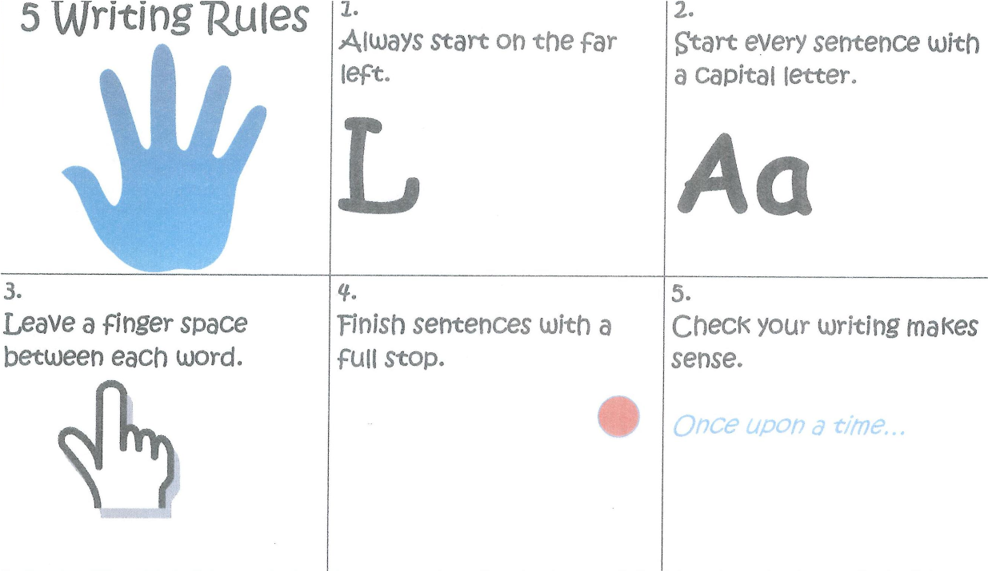

General advice to teachers
- The best marking and feedback is without doubt the dialogue that takes place between teacher and pupil while the task is being completed.
- Whenever possible, marking and feedback should involve the child directly. The younger the child, the more important it is that the feedback is oral and immediate.
- When appropriate, children may mark their own (or another child’s) work, but the teacher must always review this marking.
- In addition, the children could indicate where they think a particular target has been achieved. Their learning partners might also check on their behalf, before the work is handed in, that a particular target has been met.
- Feedback may also be given by a teaching assistant, through peer review, through plenaries and in group sessions.
- Written comments should be neat, legible and written in a contrasting colour
- Marking will normally be done before the next lesson in that subject, although this may not always be possible for longer pieces of work.

Recognising Personal Achievements
In addition to the symbols in the marking code above, individual pupils may be rewarded to recognise different levels of success. For example, stampers/stickers can be used to indicate excellent pieces of work and teachers and can reward pupils with house points.
Insight
Teachers will update Insight if and when applicable to identify gaps in learning, but at least once a term before Pupil Progress Meetings.

Religious Education
As teachers of a Catholic school, we use the driver words linked to assessment levels to ensure quality teaching and assessment of R.E in childrens books.

Equal Opportunities

All children have equal access and inclusive rights to the curriculum regardless of their gender, race, disability or ability. We plan work that is differentiated for the performance of all groups and individuals. Our Lady Immaculate Catholic Primary School is committed to creating a positive climate that will enable everyone to work free from racial intimidation and harassment and to achieve their full potential. Marking is according to prior attainment, not solely on year group expectations

Appendix 1

Whole Class Feedback Sheet Date: Lesson:
Work to Praise and Share | Need Further Support
Presentation | Basic Skills Errors
Misconceptions and Next Lesson Notes

