OUR LADY IMMACULATE CATHOLIC PRIMARY SCHOOL

“With God all things are possible”
(Matthew 19:26)

At Our Lady Immaculate Catholic Primary School, we will inspire our children to achieve personal excellence for themselves and for the glory of God.

Relationships and Sex Education Policy

Date | Review Date | Nominated Lead Member of Staff | Nominated Committee | Nominated Governor
Autumn  2023 | Autumn 2024 | Headteacher | Full Governing Body | Linda McSweeney

The RSE policy will be given to all members of the Governing Body, and all teaching and non-teaching members of staff. Copies of the document will be available to all parents through the school office. It will also be available on the school’s website.
Our Lady Immaculate is a thriving Catholic learning community with Christ at the centre. We celebrate the uniqueness of every child and aim to educate and prepare our children to be independent, confident and to live life to the full. As a Catholic learning community, everything we do serves the Church’s teaching of assisting parents as primary and principal educators to fulfil their role. Every decision is made with the children in mind, serving our Mission and following our Virtues, British Values and Global Values.

SCHOOL INTENT

In this policy the Governors and teachers, in partnership with pupils and their parents, set out their intentions about relationships and sex education (RSE). We set out our rationale for, and approach to relationships and sex education in the school.

DEFINING RELATIONSHIP AND SEX EDUCATION

The DfE guidance states that “children and young people need to know how to be safe and healthy, and how to manage their academic, personal and social lives in a positive way”. It is about the development of the pupil’s knowledge and understanding of her or him as a sexual being, about what it means to be fully human, called to live in right relationships with self and others and being enabled to make moral decisions in conscience. In primary schools the focus should be on “teaching the fundamental building blocks and characteristics of positive relationships, with particular reference to friendships, family relationships, and relationships with other children and with adults.” This would include the topics of families and the people who care for me, caring friendships, respectful relationships, online relationships and being safe. In Secondary schools RSE should “give young people the information they need to help them develop healthy, nurturing relationships of all kinds, not just intimate relationships. It should enable them to know what a healthy relationship looks like and what makes a good friend, a good colleague and a successful marriage or other type of committed relationship. It should also cover contraception, developing intimate relationships and resisting pressure to have sex (and not applying pressure).”

STATUTORY CURRICULUM REQUIREMENTS

We are legally required to teach those aspects of RSE which are statutory parts of National Curriculum Science. However, the reasons for our inclusion of RSE go further.

RATIONALE

‘I have come that you might have life and have it to the full’. (Jn.10.10)

We are involved in relationships and sex education precisely because of our Christian beliefs about God and about the human person. The belief in the unique dignity of the human person made in the image and likeness of God underpins the approach to all education in a Catholic school. Our approach to RSE therefore is rooted in the Catholic Church’s teaching of the human person and presented in a positive framework of Christian ideals.

At the heart of the Christian life is the Trinity; Father, Son and Spirit in communion, united in loving relationship and embracing all people and all creation. As a consequence of the Christian belief that we are made in the image and likeness of God, gender and sexuality are seen as God’s gift, reflect God’s beauty, and share in the divine creativity. RSE, therefore, will be placed firmly within the context of relationship as it is there that sexuality grows and develops.

Following the guidance of the Bishops of England and Wales and as advocated by the DFE (and the Welsh Assembly Government) RSE will be firmly embedded in the PSHE framework as it is concerned with nurturing human wholeness and integral to the physical, spiritual, emotional, moral, social and intellectual development of pupils. It is centred on Christ’s vision of being human as good news and will be positive and prudent, showing the potential for development, while enabling the dangers and risks involved to be understood and appreciated.

All RSE will be in accordance with the Church’s moral teaching. It will emphasise the central importance of marriage and the family whilst acknowledging that all pupils have a fundamental right to have their life respected whatever household they come from. It will also prepare pupils for life in modern Britain.

VALUES AND VIRTUES

Our programme enshrines Catholic values relating to the importance of stable relationships, marriage and family life. It also promotes those virtues which are essential in responding to the God’s call to love others with a proper respect for their dignity and the dignity of the human body. The following virtues will be explicitly explored and promoted: faithfulness, fruitfulness, chastity, integrity, prudence, mercy and compassion.

AIM OF RSE AND THE MISSION STATEMENT

Our Mission Statement commits us to the education of the whole child (spiritual, physical, intellectual, moral, social, cultural, emotional) and we believe that RSE is an integral part of this education. Furthermore, our school aims state that we will endeavour to raise pupils’ self-esteem, help them to grow in knowledge and understanding, recognise the value of all persons and develop caring and sensitive attitudes. It is in this context that we commit ourselves:

In partnership with parents, to provide children and young people with a “positive and prudent sexual education” which is compatible with their physical, cognitive, psychological, and spiritual maturity, and rooted in a Catholic vision of education and the human person.

Objectives

To develop the following attitudes and virtues:

- reverence for the gift of human sexuality and fertility;
- respect for the dignity of every human being – in their own person and in the person of others;
- joy in the goodness of the created world and their own bodily natures;
- responsibility for their own actions and a recognition of the impact of these on others;
- recognising and valuing their own sexual identity and that of others;
- celebrating the gift of life-long, self-giving love;
- recognising the importance of marriage and family life;
- fidelity in relationships.

To develop the following personal and social skills:

- making sound judgements and good choices which have integrity, and which are respectful of the individual’s commitments;
- loving and being loved, and the ability to form friendships and loving, stable relationships free from exploitation, abuse and bullying;
- managing emotions within relationships, and when relationships break down, with confidence, sensitivity and dignity;
- managing conflict positively, recognising the value of difference;
- cultivating humility, mercy and compassion, learning to forgive and be forgiven;
- developing self-esteem and confidence, demonstrating self-respect and empathy for others;
- building resilience and the ability to resist unwanted pressures, recognising the influence and impact of the media, internet and peer groups and so developing the ability to assess pressures and respond appropriately;
- being patient, delaying gratification and learning to recognise the appropriate stages in the development of relationships, and how to love chastely;
- assessing risks and managing behaviours in order to minimise the risk to health and personal integrity.

To know and understand:

- the Church’s teaching on relationships and the nature and meaning of sexual love;
- the Church’s teaching on marriage and the importance of marriage and family life;
- the centrality and importance of virtue in guiding human living and loving;
- the physical and psychological changes that accompany puberty;
- the facts about human reproduction, how love is expressed sexually and how sexual love plays an essential and sacred role in procreation;
- how to manage fertility in a way which is compatible with their stage of life, their own values and commitments, including an understanding of the difference between natural family planning and artificial contraception;
- how to keep themselves safe from sexually transmitted infections and how to avoid unintended pregnancy, including where to go for advice.

Outcomes

INCLUSION AND DIFFERENTIATED LEARNING

We will ensure RSE is sensitive to the different needs of individual pupils in respect to pupils’ different abilities, levels of maturity and personal circumstances; for example, their own sexual orientation, faith or culture and is taught in a way that does not subject pupils to discrimination. Lessons will also help children to realise the nature and consequences of discrimination, teasing, bullying and aggressive behaviours (including cyber-bullying), use of prejudice-based language and how to respond and ask for help. (In looking at these questions, it is important to draw links to the school’s inclusion policy).

EQUALITIES OBLIGATIONS

The governing body have wider responsibilities under the Equalities Act 2010 and will ensure that our school strives to do the best for all of the pupils, irrespective of disability, educational needs, race, nationality, ethnic or national origin, pregnancy, maternity, sex, gender identity, religion or sexual orientation or whether they are looked-after children.

BROAD CONTENT OF RSE

Three aspects of RSE - attitudes and values, knowledge and understanding, and personal and social skills will be provided in three inter-related ways: the whole school / ethos dimension; a cross-curricular dimension and a specific relationships and sex curriculum.

PROGRAMME / RESOURCES

Appendices to this policy provide further information about the programme and resources for suggested use.

Teaching strategies will include:

- establishing ground rules
- distancing techniques
- discussion
- project learning
- reflection
- experiential
- active
- brainstorming
- film & video
- group work
- role-play
- trigger drawings
- values clarification

Assessment

Assessment and evaluation is carried out by the class teacher, RE coordinator, and SLT to ensure consistency with the school’s policy. Pupils’ knowledge, understanding and skills will be assessed through pupil self-assessment, peer group assessment, teacher assessment and whole school monitoring programme which includes staff, parents and governors.

PARENTS AND CARERS

We recognise that parents (and other carers who stand in their place) are the primary educators of their children. As a Catholic school, we provide the principal means by which the Church assists parents and carers in educating their children. Therefore, the school will support parents and carers by providing material to be shared with their children at home and workshops to help parents/carers to find out more. Parents/carers will be informed by letter when the more sensitive aspects of RSE will be covered in order that they can be prepared to talk and answer questions about their children’s learning.

Parents must be consulted before this policy is ratified by the governors. They will be consulted at every stage of the development of the RSE programme, as well as during the process of monitoring, review and evaluation. They will be able to view the resources used by the school in the RSE programme. Our aim is that, at the end of the consultation process, every parent and carer will have full confidence in the school’s RSE programme to meet their child’s needs.

Parents continue to have the right to withdraw their children from Sex Education except in those elements which are required by the National Curriculum science orders. Should parents wish to withdraw their children they are asked to notify the school by contacting the headteacher. The school will provide support by providing material for parents to help the children with their learning.
We believe that the controlled environment of the classroom is the safest place for this curriculum to be followed. Please refer to the DfE guidance Page 17 for further details on the right to be excused from sex education (commonly referred to as the right to withdraw).

BALANCED CURRICULUM

Whilst promoting Catholic values and virtues and teaching in accordance with Church teaching, we will ensure that pupils are offered a balanced programme by providing an RSE programme that offers a range of viewpoints on issues.

Pupils will also receive clear scientific information as well as covering the aspects of the law pertaining to RSE (in secondary schools/academies relating to forced-marriage, female genital mutilation, abortion, the age of consent and legislation relating to equality). Knowing about facts and enabling young people to explore differing viewpoints is not the same as promoting behaviour and is not incompatible with our school’s promotion of Catholic teaching. We will ensure that pupils have access to the learning they need to stay safe, healthy and understand their rights as individuals.

RESPONSIBILITY FOR TEACHING THE PROGRAMME

Responsibility for the specific relationships and sex education programme lays with the relevant curriculum staff; this will normally include science, religious education, physical education, RSE and PSHE Leads).

However, all staff will be involved in developing the attitudes and values aspect of the RSE programme. They will be role models for pupils of good, healthy, wholesome relationships as between staff, other adults and pupils. They will also be contributing to the development of pupils’ personal and social skills.

External Visitors

Our school will often call upon help and guidance from outside agencies and health specialists to deliver aspects of RSE. Such visits will always complement the current programme and never substitute or replace teacher led sessions. It is important that any external visitor is clear about their role and responsibility whilst they are in school delivering a session. Any visitor must adhere to our code of practice developed in line with CES guidance ‘Checklist for External Speakers to Schools. Health professionals should follow the school’s policies, minimising the potential for disclosures or inappropriate comments using negotiated ground rules and distancing techniques as other teachers would. They will ensure that all teaching is rooted in Catholic principles and practice.

OTHER ROLES AND RESPONSIBILITIES REGARDING RSE

Governors
- draw up the RSE policy, in consultation with parents and teachers;
- ensure that the policy is available to parents;
- ensure that the policy is in accordance with other whole school policies, e.g., SEN, the ethos of the school and our Christian beliefs;
- ensure that parents know of their right to withdraw their children;
- establish a link governor to share in the monitoring and evaluation of the programme, including resources used;
- ensure that the policy provides proper and adequate coverage of relevant National Curriculum science topics and the setting of RSE within PSHE.

Headteacher

The Headteacher takes overall delegated responsibility for the implementation of this policy and for liaison with the Governing Body, parents, the Diocesan Schools’ Service and the Local Education Authority, also appropriate agencies.

PSHE/RSE Co-ordinator

The co-ordinator with the headteacher has a general responsibility for supporting other members of staff in the implementation of this policy and will provide a lead in the dissemination of the information relating to RSE and the provision of in-service training.

All Staff

RSE is a whole school issue. All teachers have a responsibility of care; as well as fostering academic progress they should actively contribute to the guardianship and guidance of the physical, moral and spiritual well-being of their pupils. Teachers will be expected to teach RSE in accordance with the Catholic Ethos of the school. Appropriate training will be made available for all staff teaching RSE. All staff have been included in the development of this policy and all staff should be aware of the policy and how it relates to them.

RELATIONSHIP TO OTHER POLICIES AND CURRICULUM SUBJECTS

This RSE policy is to be delivered as part of the PSHE framework. It includes guidelines about pupil safety and is compatible with the school's other policy documents (for example, Bullying policy, Safeguarding Policy etc)

Pupils with particular difficulties whether of a physical or intellectual nature will receive appropriately differentiated support in order to enable them to achieve mature knowledge, understanding and skills. Teaching methods will be adapted to meet the varying needs of this group of pupils.

Learning about RSE in PSHE classes will link to/complement learning in those areas identified in the RSE audit.

CHILDREN’S QUESTIONS

The governors want to promote a healthy, positive atmosphere in which RSE can take place. They want to ensure that pupils can ask questions freely, be confident that their questions will be answered, and be sure that they will be free from bullying or harassment from other children and young people.

Controversial or Sensitive issues

There will always be sensitive or controversial issues in the field of RSE. These may be matter of maturity, of personal involvement or experience of children, of disagreement with the official teaching of the Church, of illegal activity or other doubtful, dubious or harmful activity. The governors believe that children are best educated, protected from harm and exploitation by discussing such issues openly within the context of the RSE programme. The use of ground rules, negotiated between teachers and pupils, will help to create a supportive climate for discussion. (See also Relationships Education, Relationships and Sex Education (RSE) and Health Education, Managing difficult questions, Page 23 for more detail)

Some questions may raise issues which it would not be appropriate for teachers to answer during ordinary class time, e.g., where a child or young person’s questions hints at abuse, is deliberately tendentious or is of a personal nature.

SUPPORTING CHILDREN AND YOUNG PEOPLE WHO ARE AT RISK

Children will also need to feel safe and secure in the environment in which RSE takes place. Effective RSE will provide opportunities for discussion of what is and is not appropriate in relationships. Such discussion may well lead to disclosure of a safeguarding issue. Teachers will need to be aware of the needs of their pupils and not let any fears and worries go unnoticed. Where a teacher suspects that a child or young person is a victim of or is at risk of abuse they are required to follow the school’s safeguarding policy and immediately inform the designated senior member of staff responsible.

CONFIDENTIALITY AND ADVICE

All governors, all teachers, all support staff, all parents and all pupils must be made aware of this policy, particularly as it relates to issues of advice and confidentiality.
All lessons, especially those in the RSE programme, will have the best interests of pupils at heart, enabling them to grow in knowledge and understanding of relationships and sex, developing appropriate personal and social skills and becoming appreciative of the values and attitudes which underpin the Christian understanding of what it means to be fully human.

Pupils will be encouraged to talk to their parents/carers about the issues which are discussed in the programme. Teachers will always help pupils facing personal difficulties, in line with the school’s pastoral care policy. Teachers should explain to pupils that they cannot offer unconditional confidentiality, in matters which are illegal or abusive for instance. Teachers will explain that in such circumstances they would have to inform others, e.g., parents, headteacher, but that the pupils would always be informed first that such action was going to be taken.

MONITORING AND EVALUATION

The RSE Co-ordinator will monitor the provision of the various dimensions of the programme by examining plans, schemes of work and samples of pupils work at regular intervals. The programme will be evaluated biannually by means of questionnaires / response sheets / needs assessment given to pupils, and / or by discussion with pupils, staff and parents. The results of the evaluation should be reported to these groups of interested parties and their suggestions sought for improvements. Governors will consider all such evaluations and suggestions before amending the policy. Governors remain ultimately responsible for the policy.

APPENDIX 1
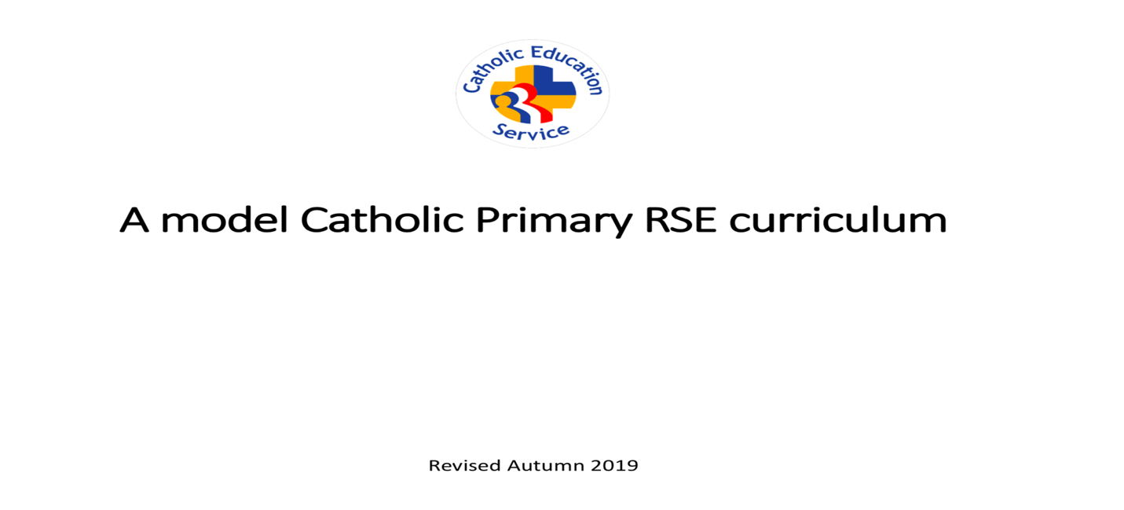

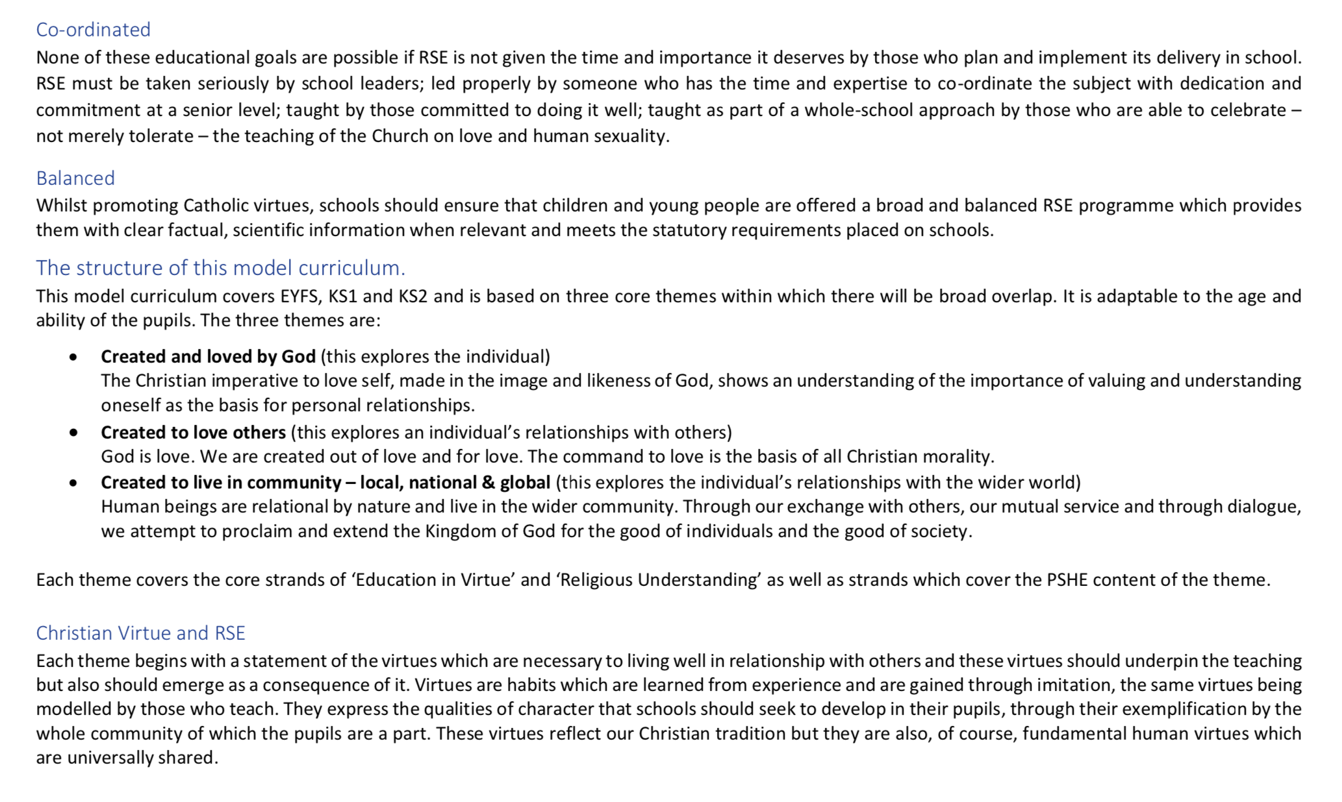
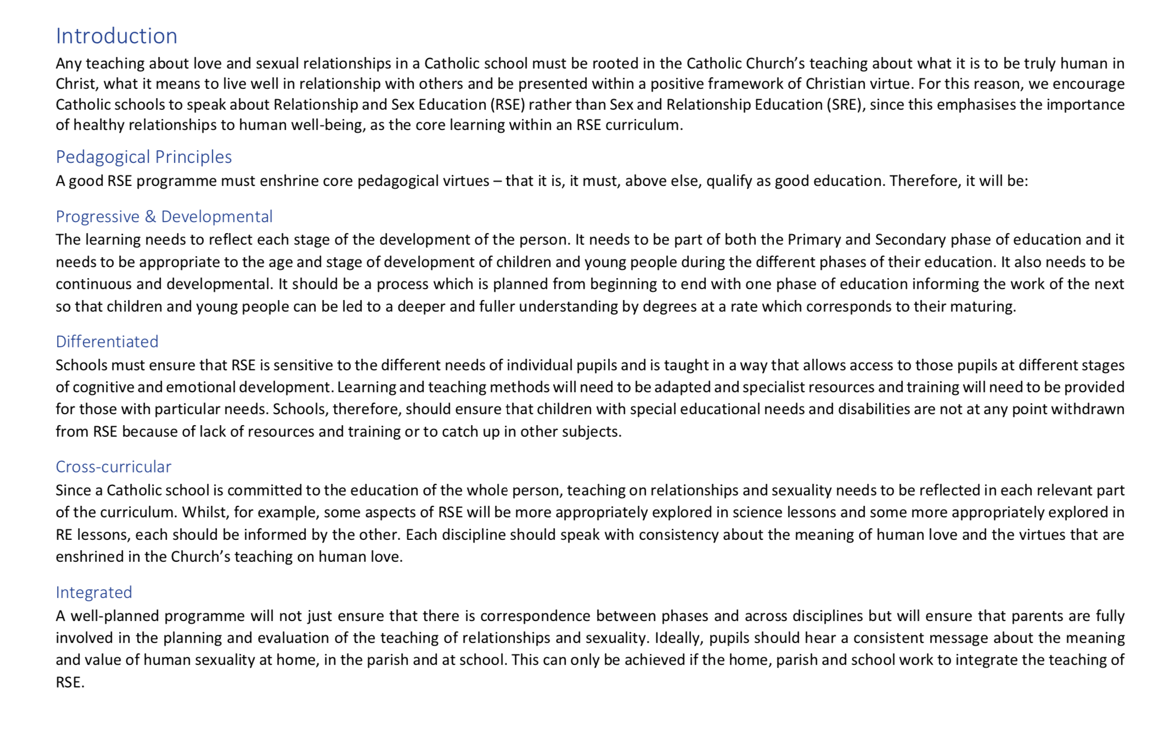
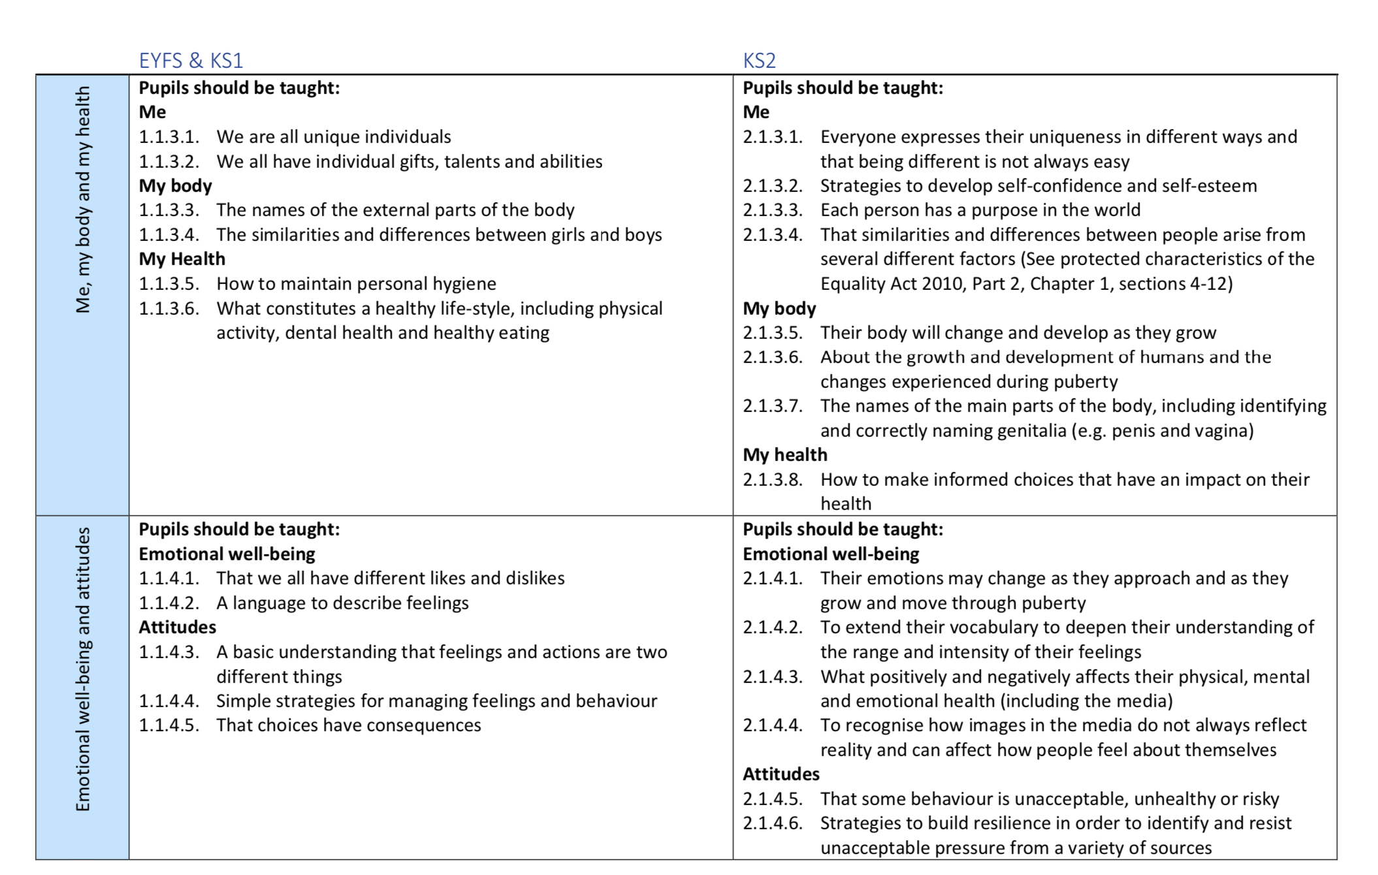
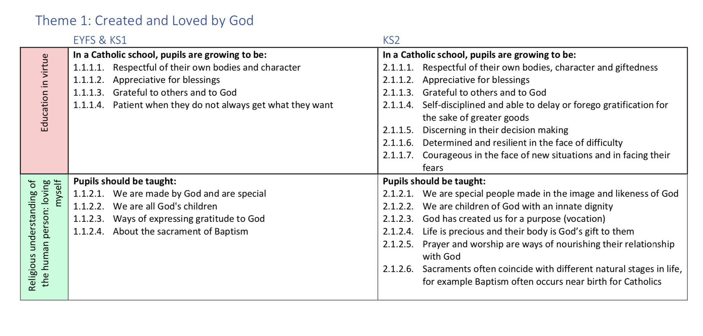
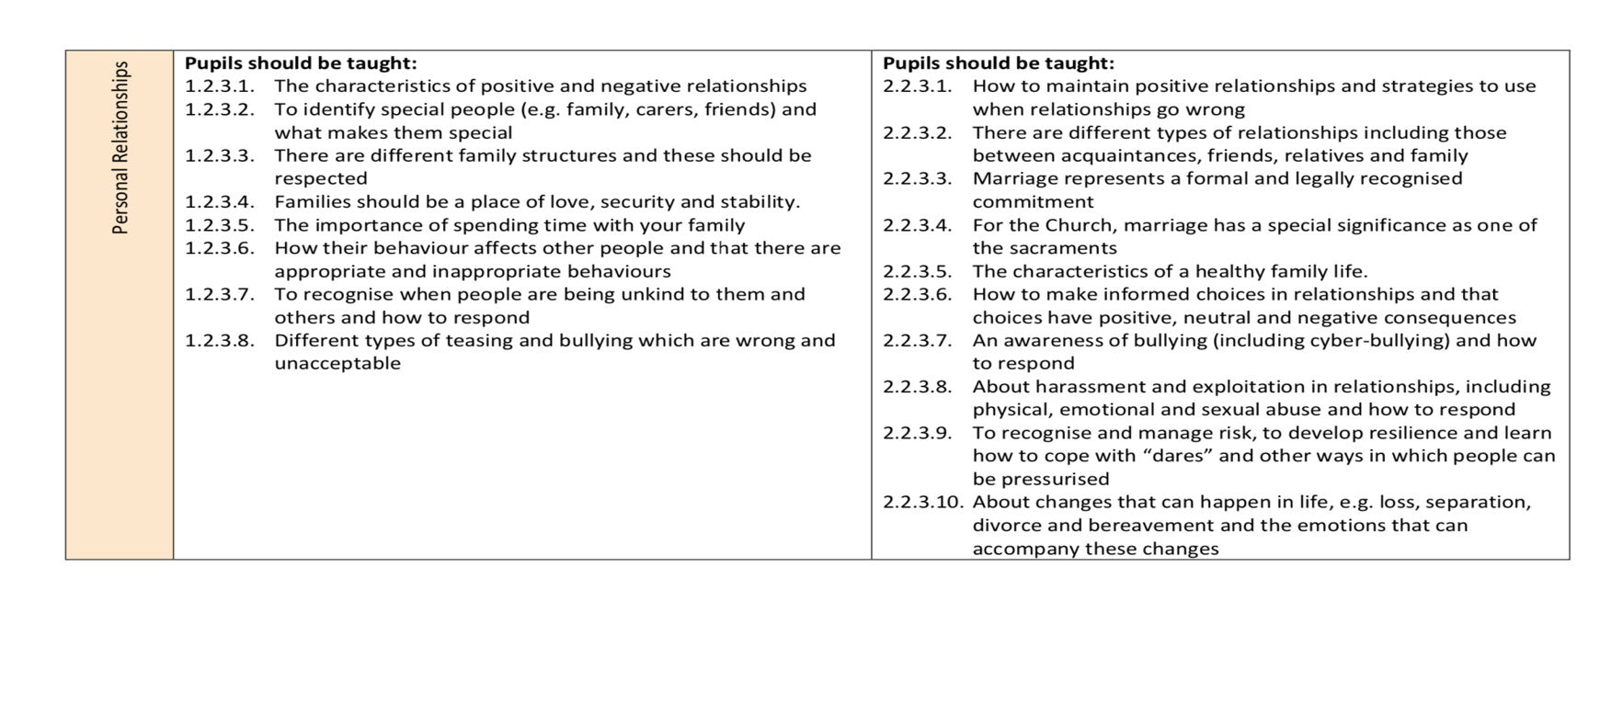
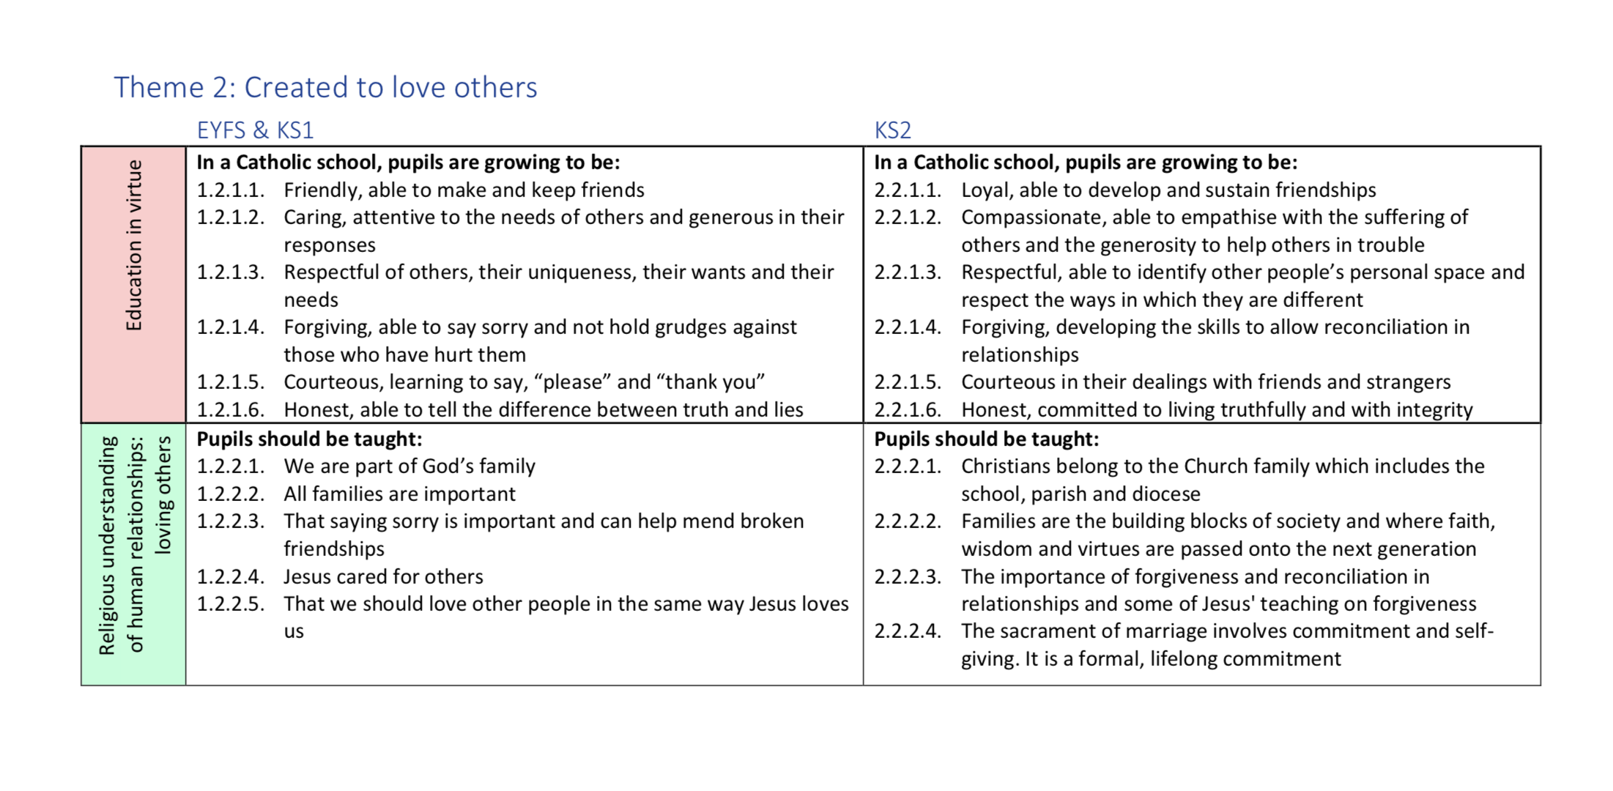
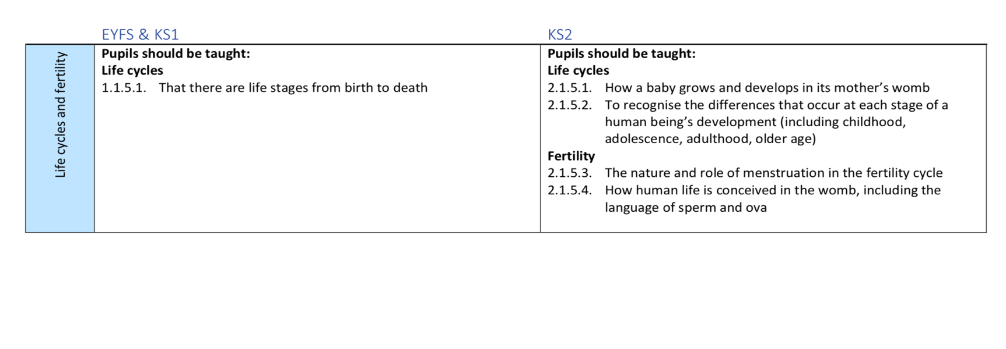
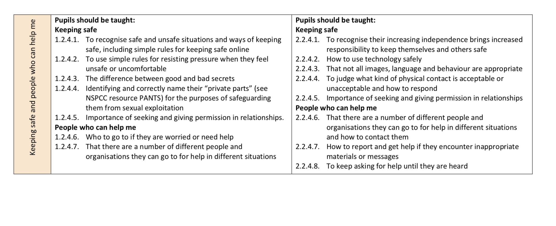

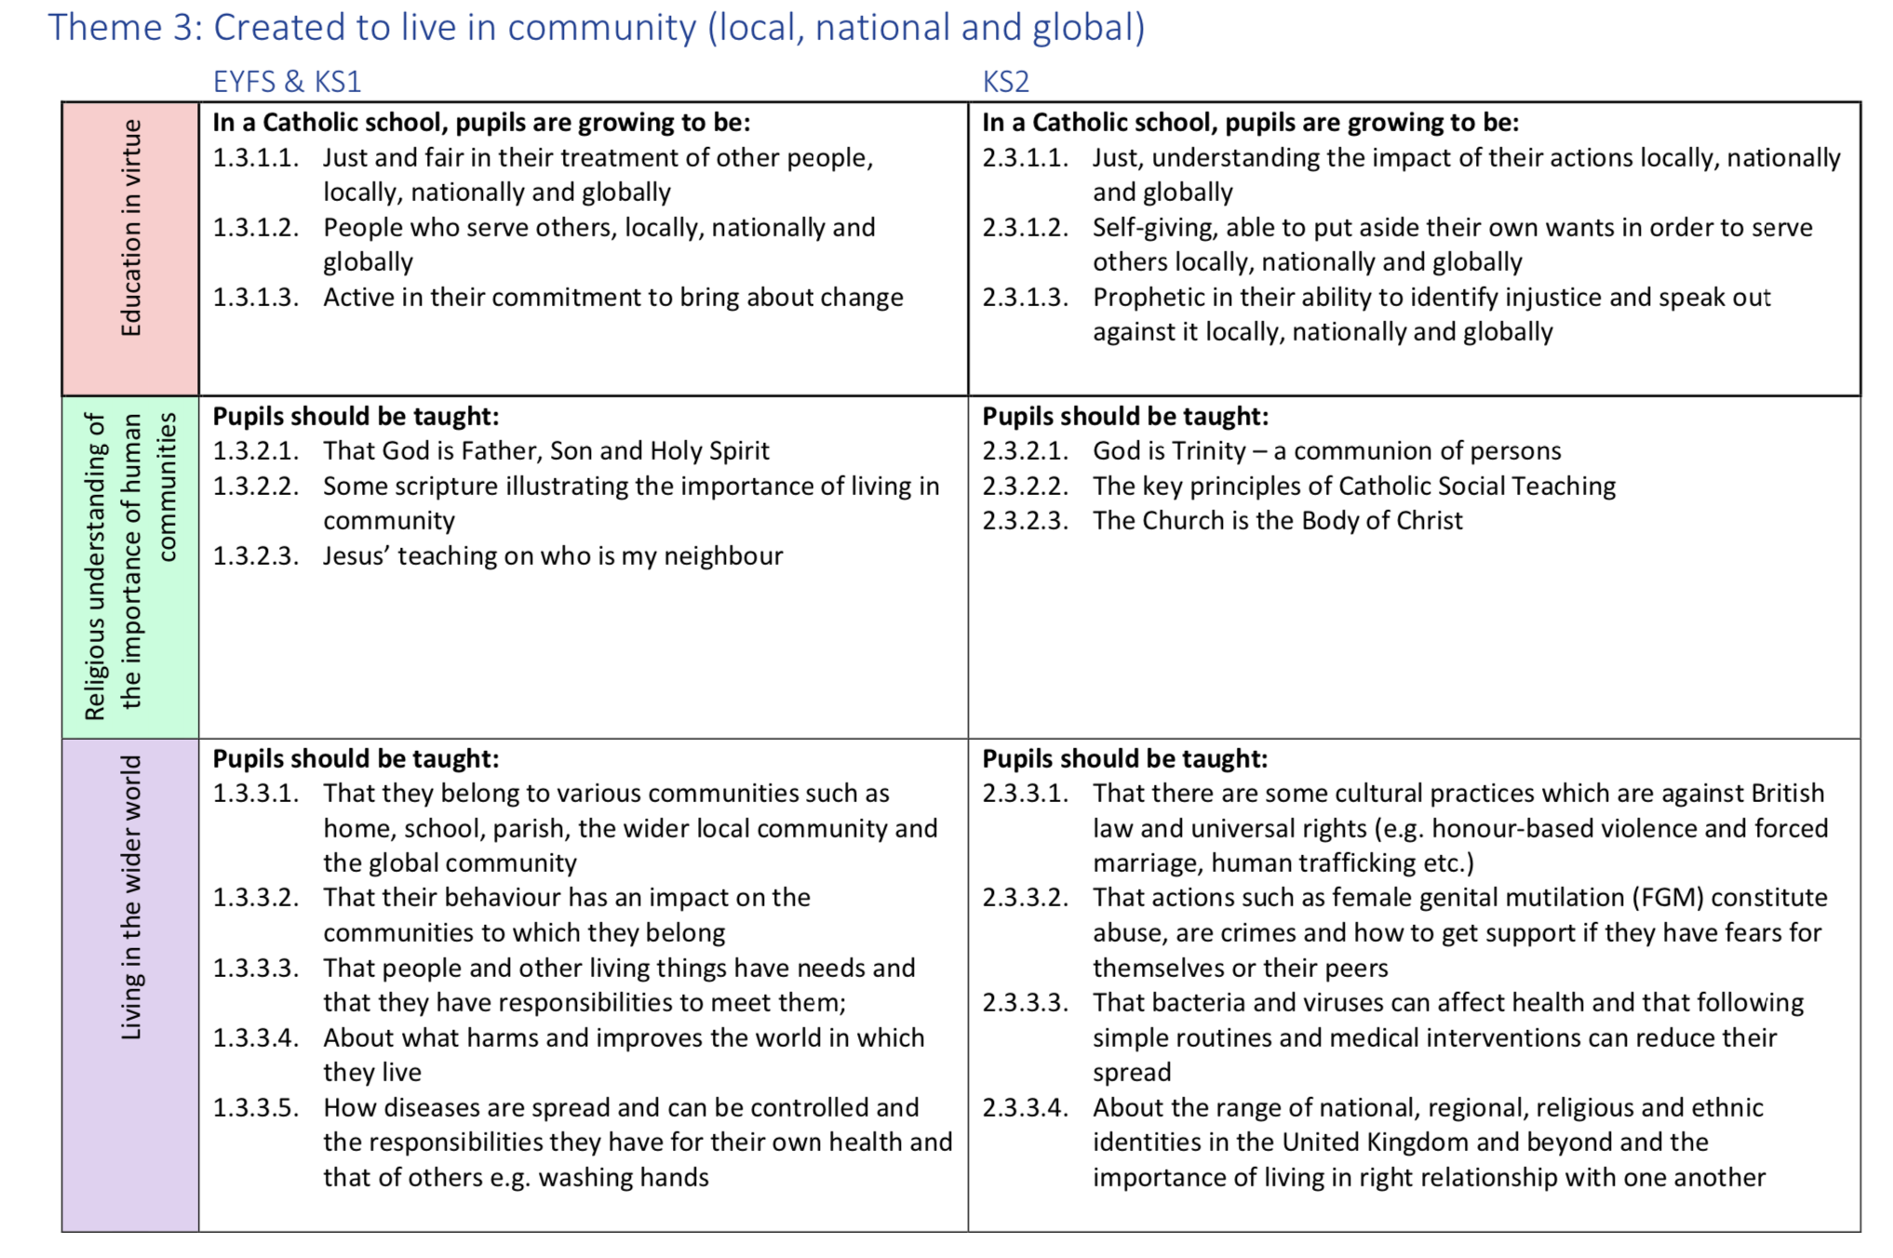

Appendix 2
Primary Safety Skills Ladder Key Stage 1 & 2
E-Safety
Keeping Healthy
Relationships and Sex Education
Staying Safe including Drug Education
Year 1
I can name the main parts of the body and know that we are created in God’s image
I understand differences between male and female and can name the main parts of the body.
I know which areas of the body are private.
I understand that babies become children and then adults.
I know how to look after my body.
I know that there are different kinds of relationships – family, friends and others.
I know that there are different types of families.
I can say people who are special to me, what makes them special and how special people should care for one another.
I know family and friends should care for each other.
I know there are good and bad secrets.
I can judge what kind of physical contact is acceptable, unacceptable, comfortable and uncomfortable and how to respond (Including who to tell and how to tell them).
I understand that people’s bodies and feelings can be hurt (including what makes them feel comfortable and uncomfortable).
I know the role of medicines in promoting health and the reasons why people use them.
I know the school rules about personal hygiene and medicines
I know that there are healthy and less healthy drinks and some drinks that are for adults (e.g coffee, alcohol).
I recognise the need for safety rules – road, fire, school environment, playground and home.
I know there are people and services who can help us
I know simple rules about medicines and other substances used in the home, including solvents (bleach, cleaning product) and that they can be harmful if not used properly.
I know the importance of personal hygiene – regular washing, bathing, showering
I know what my body needs to stay healthy, including physical activity, rest, healthy eating and oral health
I know that change and loss can affect feelings, including moving home, losing pets, friends, or family.
I know who to go to if I am worried
I understand that I can find a range of information from the internet
I can navigate age-appropriate websites. I know what to do if I find something inappropriate online.
I know that the internet can be used to communicate with others.
I understand that we should respect the work of others which is stored or presented electronically.

Year 2
I use appropriate language for body parts.
I know which parts of my body are private.
I know the difference between male and female humans and animals.
I understand the importance of valuing of one’s own body and recognising its uniqueness.
I know that individuals have rights over their own bodies, and that there are differences between good and bad touching (PANTS are Private – NSPCC link).
I know that people can do different things according to age and development and that people grow from young to old.
I know some people have fixed ideas about what boys and girls can do.
I know that there are good and bad secrets.
I know I share a responsibility to keep myself and others safe, when to say, yes, no, I’ll ask, I’ll tell...
I can recognise, name and deal with my feelings in a positive way.
I know that other peoples’ families are different to mine.
I can listen to other people.
I use simple skills which will help to maintain my personal safety including staying safe around hazardous or unknown substances alone or with friends.
I understand that all drugs (cough syrup, paracetamol, Calpol, caffeine, alcohol) can be harmful if not used properly.
I know the dangers from handling discarded syringes and needles.
I know who to go to if I need help or am worried.
I can make simple choices to improve my health and well-being.
I know that change and loss can affect feelings, including moving home, losing pets, or family.
I can use the internet purposefully and safely to answer specific questions.
I know that not everything on the internet is true.
I am able to send suitable and purposeful emails with help.
I can demonstrate an understanding of E-safety when communicating online.
I am aware that people communicate using social media/gaming and the importance of privacy and staying safe.

Year 3
I can identify different types of relationships and show ways to maintain good relationships.
I understand that relationships may change over time
I can judge what kind of physical contact is acceptable or unacceptable
I know who to go to if I need help
I understand that all families are different and have different family members
I can describe how my body has changed since I was a baby
I can judge what kind of physical contact is acceptable or unacceptable
I know that individuals have rights over their own bodies and there are differences between good and bad touching
I understand about personal space
I know how to deal with unwanted touch
I know who to go to if I needed help
I know that marriage and civil partnerships are examples of loving relationships
I can make simple choices to improve my health and well-being, including healthy eating, physical exercise, oral health and emotional wellbeing
I can identify and explain how to manage the risks in different familiar situations.
I can make judgements and decisions and use basic techniques for resisting negative peer pressure
I can list the commonly available substances and drugs that are legal (cough medicine, paracetamol, Calpol, caffeine, alcohol) and illegal (tobacco) and describe some of the effects and risks of these
I know how to keep myself and others safe when using roads
I know school rules relating to medicines, alcohol, tobacco, and illegal drugs
I understand that it is alright to break a secret in order to keep me safe
I can use the internet purposefully and safely to answer specific questions.
I know that not everything on the internet is true
I know the difference and risks of communicating using email and online in a discussion forum
I am able to send suitable and purposeful emails
I can demonstrate an understanding of E-safety when communicating online

Year 4
I feel good about myself and my body
I know the importance of taking care of my own body
I know I have the right to protect my body from inappropriate and unwanted contact
I understand the language used to describe feelings and changes
I understand the main stages of the human life cycle
I know some of the ways that my body and emotions will change as I grow into an adult through the stages of puberty including physical differences (height, weight, perspiration, changes in skin)
I know that puberty is linked to reproduction
I know the names for different male and female body parts and introduce their functions
I can respond appropriately to other people’s feelings
I can describe some of the different beliefs and values in society and demonstrate respect and tolerance towards people different from me
I am aware of different types of relationships including those between friends and families, civil partnerships and marriage
I can identify some factors that affect emotional health and wellbeing e.g. relationships with family and friends, stress levels, physical activity, diet, self-image, media
I can make informed choices about healthy eating and exercising
I can use the internet as a resource to support my work, and begin to understand plagiarism
I know that not everything on the internet is true and know what to do if I access something inappropriate
I can use a range of online communication tools to exchange information and collaborate with others within and beyond my school e.g. school blogs, email, instant messaging, social networking, online gaming and mobile phones
I understand the need to keep some information private in order to protect myself when communicating online (passwords, address, distributing images of myself and others)
I begin to recognise how electronic communications may be used for manipulation or persuasion
I can take responsibility for my own choices, behaviour and safety and realise that actions have consequences
I can begin to understand some of the influences on my personal choices in relation to smoking or other substances (caffeine, alcohol, tobacco) and the consequences of those choices
I have some strategies to cope with peer influence and peer pressure and can apply these to a range of scenarios
I know who to go to if I need help

Year 5
I can name the parts of the male and female reproductive organs
I know and explain the ways in which boys and girls grow and develop in puberty physically and emotionally
I understand how to manage the physical and emotional changes of puberty
I understand the importance of good hygiene routines as I grow into an adult
I know where I can get support during puberty both within and outside of school
I know where individuals, families and groups can get help and support
I understand the safe and simple routines to prevent the spread of bacteria and viruses
I am aware of different types of relationships including those between friends and families, civil partnerships and marriage
I recognise that as I approach puberty, how people’s emotions change and how to deal with my feelings towards myself, my family and others in a positive way
I know where individuals, families and groups can get support
I know that marriage is a commitment freely entered into by both people and that no one should enter a marriage if they don’t want to
I know what makes a healthy relationship and understand that sometimes people make bad choices and abuse the person they are in a relationship with
I am aware that differences and similarities between people arise from a number of factors including family, cultural, ethnic, racial and religious diversity, age, sex, sexual orientation and disability
I can identify a range of risks connected to realistic and relevant drug situations for my age
I understand the influence of peers in making risky or unsafe choices and feel confident to deal with these influences
I know which commonly available substances and drugs are legal and illegal, their effects and risks and can identify and use strategies to reduce those risks
I know the dangers from handling discarded syringes and needles
I understand the concept of ‘keeping something confidential or secret’, when we should or should not agree to this and when it is right to ‘break a confidence’ or ‘share a secret’
I know who to go to if I need help
I know what makes a healthy lifestyle - the benefits of exercise and healthy eating and the factors that affect mental health, including positive self-image
I know how to make informed healthy lifestyle choices
I can recognise the need to ask appropriate questions to find answers
I understand that good online research involves processing the information (rather than copying) and interpreting it for others
I recognise that not all information on the internet is accurate or unbiased (advertising) and am able to develop strategies for identifying the origin of a website
I recognise issues of copyright and the importance of acknowledging sources
I can use online tools to exchange information and collaborate with others within and beyond my school and begin to evaluate their effectiveness
I understand the potential risks of providing personal information in an increasing range on online technologies both within and outside school, including the distribution of images of myself and others
I recognise my own right to be protected from the inappropriate use of technology by others and the need to respect the rights of other users
I can evaluate my own use of web-publishing tools and how I present myself on-line

Year 6
I recognise different risks in different situations and then decide how to behave responsibly, including judging what kind of physical contact is acceptable or unacceptable
I can name and explain the human reproductive organs in males and females
I know the ways in which boys and girls grow and develop in puberty to prepare the body for reproduction and that this can happen at different times
I know some facts about human reproduction including conception, pregnancy and birth and that conception can be prevented by the use of contraception
I understand that there are lots of things to consider before having a baby
I know how to keep my body healthy and clean during puberty
I recognise that as I approach puberty how peoples’ emotions change at that time and how to deal with my feelings towards myself, others and my family in a positive way
I know some of the reasons why adults choose to have sex in a relationship and that this can be influenced by cultural and religious views
I know that female genital mutilation is a crime and how to get support if I have fears about myself and others
I am able to recognise and challenge stereotypes
I realise the nature and consequences of discrimination, teasing, bullying and aggressive behaviours and how to respond to this and ask for help
I know some of the ways that people show they love and care for each other in a relationship
I understand that there are different types of adult relationship and can explain the qualities of a positive relationship
I have thought about when it is appropriate to share personal information in a relationship
I know families are important for having babies and bringing them up
I understand that abuse in relationships is against the law and know where people can go for help in this situation
I know that civil relationships and marriage are a public demonstration of the commitment made between two people who love and care for each other and want to spend their lives together and who are of the legal age to make that commitment.
I know that there are some cultural practices which are against the law and universal rights e.g honour based violence, forced marriages, human trafficking etc.
I understand the effects, risks and consequences of drug use on the body and mind, including addiction and the effect on young children who are still growing.
I know basic emergency aid procedures (IMPS)
I know that pressure to behave in an unacceptable or risky way (social media, relationships) can come from a variety of sources, including people I know
I know how to ask for help and have a range of strategies to resist pressure and distinguish between positive and negative influences
I understand the influence of the media in relation to alcohol and drugs and know where to access reliable sources of information and support around substances (FRANK)
I understand the basic law in relation to substances
I understand that there are a range of influences for example the media that can have an effect on physical and emotional health and wellbeing.
I recognise that not all information on the internet is accurate or unbiased (advertising) and develop a range of strategies for identifying the origin of a website
I understand the issues of plagiarism, copyright and data protection in relation to my work
I can select appropriate tools to collaborate and communicate confidently and safely with others within and beyond my school
I can exchange and share ideas with a wider audience, and evaluate my use of technology
including the use of email, social networking, online gaming, and mobile phones and how I present myself online (CEOP Resources, Sexting, Internet Footprint and Traceability)
I understand the importance of protecting personal information, including passwords, addresses and images

Relationships Education, Relationships and Sex Education (RSE) and Health Education: Statutory guidance for governing bodies, proprietors, head teachers, principals, senior leadership teams, teachers Page 4
Relationships Education, Relationships and Sex Education (RSE) and Health Education: Statutory guidance for governing bodies, proprietors, head teachers, principals, senior leadership teams, teachers Page 19
Relationships Education, Relationships and Sex Education (RSE) and Health Education: Statutory guidance for governing bodies, proprietors, head teachers, principals, senior leadership teams, teachers Page 25
_{Gravissimum Educationis 1}
CES Checklist for External Speakers to Schools, 2016

